港澳兒童教育國際協會通訊
Newsletter of The Association for Childhood Education
International –Hong Kong & Macau
2003年12月 December 2003

President’s Message: Taking Action & Meeting New Challenges
Ramsey D. Koo

As the founding and re-elected President of the ACEI-HKM for 2003-2005, I wish to express my gratitude by saying that it is both a privilege and a great pleasure to serve ACEI-Hong Kong & Macao and you for another term in this important role and position. During my last term, I was very glad to have the advice and full support of members of ACEI-HKM together with the professional assistance and effective communication from ACEI Headquarters (Maryland, USA). In particular, I wish to thank all members of the ACEI-HKM Executive Board for their continued support and effort in promoting educational exchange and collaboration as well as their genuine concerns in the well-beings of children in Hong Kong, Macao and mainland China. It is also encouraging to know that members of ACEI-HKM have realized that we are a very fast growing and dynamic organization. Historically, on 15 June, 1999, our branch was registered with the Government of Hong Kong under the Certificate of Registration of Society in Section 5A(1), Chapter 151 of the Societies Ordinance. Since then, we have been working altogether enthusiastically to initial and complete a number of exciting and challenging tasks and activities in Hong Kong, Macao and mainland China, including fund raising, rebuilding schools in rural Xian, carrying out small scale research and ACEI-HKM/ Macao Government research projects, organizing education workshops and seminars, sponsoring and monitoring book publications in various fields of education, etc. Despite there are over 130 branches of ACEI worldwide, ACEI-HKM is the only branch operating in mainland China under the One Country Two Systems context. Currently, ACEI-HKM is a member of the Hong Kong Teachers’ Centre Advisory Management Committee within which an executive member is representing our branch under the category Subject-Related Organizations. More importantly, ACEI-HKM is represented by a diverse group of individuals from Hong Kong and Macao -- strengthened by our unity, our similarities and differences, our values and commitment to education and well-beings of children in an increasingly globalized world. By respecting and connecting with each other, we feel more confident, grow stronger, gain insights and empathy, challenge social injustice and current educational practice, and widen our scope and horizon as we move along and forward into the challenging future. There is no doubt that we have all accomplished a wonderful milestone in the making of a dynamic and productive association. The support and contribution that you offer to ACEI-HKM help to sustain our work and mission for the improvement of education and peoples’ live around us. Now, as we are approaching the end of 2003, may I take this opportunity to wish you all the best for the coming year!
聯絡地址﹕大埔露屏路10號香港教育學院教育政策與行政系轉古鼎儀博士
(港澳兒童教育國際協會)
本會網址﹕http://www.acei-hkm.org.hk 通訊主編﹕羅耀珍博士

2002/03港澳地區教育交流計劃 古鼎儀博士
校本管理是香港和澳門學校面對廿一世紀社會變遷和教育改革的一個重要發展的目標和策略取向。2002-03 年度〈港澳兒童教育國際協會〉(ACEI – HKM) 與港澳兩地政府教育機構及一些學校和教育工作者進行了一連串有關校本管理的交流和研討活動。此計劃獲得地區教師專業交流計劃贊助，香港方面的參與代表包括本會執委會和會員、香港教師中心、李小鵬校長 (玫瑰崗學校---小學部)、康一橋校長(香港道教聯合會青松中學)和葉建源講師(香港教育學院)等。

教育交流活動
首先，在2002年下旬，本會有關代表和教育工作者曾前往澳門作專業交流和探討校本管理的概況。澳門教育工作者也於2003年2月21日來港與香港教育工作者及本會進行校本經驗分享、學校簡介、課堂參觀及小組研討。早上參觀玫瑰崗學校、午飯後前往香港北角教師中心和觀塘秀茂坪道教聯合會青松中學與校長和行政人員及學生議會分享校本管理和學校發展等經驗。晚上本會幹事及各港澳教育工作代表出席香港童軍總會金淘軒酒家晚宴，並接受本會有關港澳校本管理的訪問和致謝。2 月22日港澳嘉賓及ACE-HKM 執委和會員共同出席香港教師中心於大角咀官立嘉道理爵士中學所舉辦的2003年度 《課程改革與教學實踐》教育研討會議。當天港澳校本管理的分享由本人主持，內容如下﹕
講者 | 講題
賴柏生(港澳兒童教育國際協會執委) | 香港校本管理的變革
阮宇華(澳門培華中學校長) | 澳門校本管理：培華中學
梁祐澄(高美士中葡小學校長) | 中葡學校校長管理個案
胡少偉(港澳兒童教育國際協會執委) | 看澳門學校的校本管理
孔智剛(澳門天主教聯會) | 回應港澳校本管理

港澳校本管理交流光碟
本會於2002/03年度地區教師專業交流計劃中得到港澳兩地政府和民間教育機構與及教育工作者的支持和參與，為本會港澳兩地教育交流和合作邁進另一個新里程。由於歷史條件及地區政治和經濟情況各異，港澳校本管理的發展模式各具不同的取向和特色。為配合港澳兩地學校發展的情況，本會特別編制了一隻教育光碟以介紹港澳校本管理交流的背景、學校特色和活動花絮。從兩地學校的專訪和交流活動中，我們可以瞭解官立和私營學校的校本管理特色和風格及其理念背景和實踐策略，從中瞭解兩地學校教育的未來發展方向和面臨的挑戰。光碟的內容主要包括五部份：港澳校本管理的交流、校本管理的理念、香港校本管理的實踐、澳門校本管理的經驗分享及校本管理的發展與挑戰。

本會光碟的節目編制小組成員為古鼎儀、甘志強、賴柏生、胡少偉、李小鵬和容萬城。光碟版權為港澳兒童教育國際協會。歡迎港澳和海外教育團體致函免費索取或電郵 rkoo@ied.edu.hk 2002-03年度地區教師專業交流計劃是港澳兒童教育國際協會的一項重要教育發展項目。本會希望在不久的將來能夠舉辦更多這類型的交流活動和講座，使兩地教育機構和前線教育工作者能更具備多元化和親歷其境的學習經驗。透過港澳兩地的教育交流和合作，可以擴闊我們視野和進一步瞭解地區的具體教育發展情況和問題，並且進一步去反思和作出有效的改善和創新。
港澳兒童教育國際協會

就香港協調學前服務工作小組諮詢文件的回應

港澳兒童教育國際協會，為兒童教育國際協會的港澳地區分會，於一九九九年創立，以促進港澳地區關心兒童教育人仕的教育交流、研究及發展為宗旨。本會目標包括﹕促進兒童在家庭、幼兒教育機構、學校及社區中享有天賦的權利、教育及福利﹔促進各兒童照顧及發展機構的服務工作水準﹔增強公眾對兒童權利及需要的關懷，與及關注一切能達致這目標的方法。本會的執委會知悉教育署及社會褔利署於二零零二年四月出版了協調學前服務工作小組諮詢文件﹕此文件對香港日後兒童教育有深遠的影響。故本執委會特就此文件作出下列的回應，原文曾刊登於二零零二年七月四日的大公報。

- 根據國際兒童教育協會的網頁資料 (網址﹕www.udel.edu/bateman/acei/wguides.) “廿一世紀幼兒教育與照顧的全球性指引”，在整體目標中提出要幼兒得到最佳成長，必須讓他們在出生後不論在家庭內外也得到合適的培育和教育﹔並應全面關注兒童早期在健康、教育和社會心理等方面的發展﹔與此同時，我們應視兒童照顧與教育的責任是家庭、教師、照顧員及社區的共同責任。故此本執委會不贊成諮詢文件中把零至六歲的幼兒教育與照顧分割成兩個階段，由兩個政府部門及法例來規管。再者，此文件內的建議對業界具指標作用，我們不希望官方的文件鼓勵業界給予幼兒分割式的服務!
- 諮詢文件回顧香港的幼兒服務，一直關注提高學前教育質素和統一學前服務的事宜。1981年《小學教育及學前服白皮書》、1986年《教育統籌委員會二號報書》和1995年《幼稚園教育作小組 (重組) 報告書》均提出以統一學前服務為長遠目標，可見香港社會一直以來的訴求都是爭取統一的幼兒教育及照顧服務。諮詢文件中只提出協調日間幼兒及幼稚園，當中的架構無論在教育理念及行政上，均未能顯示幼兒教育與照顧的揉合﹔亦無助建構零至六歲幼兒教育完整的課程，及與相關機構服務統一的目標相距甚遠。
(3) 本港人口出生率正逐漸下降，此乃政府正面承擔兒童教育的好時機，惟這份諮詢文件只強調不減現有的服務，卻沒有研究或考慮為本港兒童提供較佳的幼兒教育及照顧服務。根據本會所知，澳門政府已經實行十年義務教育，其中為澳門學童提供一年的幼稚園教育服務。相比之下，本港政府只提供九年免費的小學及初中教育，是否也應該考慮為兒童提供免費的幼兒教育，才算是合理呢!
(4) 最後在諮詢文件建議為服務兩至六歲兒童的機構成立一個聯合辦事處，並強調向有關提供服務機構的雙重規管，頗有架床屋之嫌。本會希望特區政府不要只從行政角度去解決有關問題，而應以兒童為本的原則，成立一個統一機構，全面負責零至六歲兒童的教育及照顧服務﹔當中不單有利學前兒童的教育及照顧服務的長遠發展，亦可向相關機構推出較合理的規管，及更有效的提高幼兒教育工作人員的專業地位。

最新出版

本會於二零零三年十月出版了《教育發展與課程革新﹕兩岸四地的視域和經驗》一書，當中共收集了二十四篇來自中國大陸、台灣、香港和澳門等地區的教育論文。內容分為四個部份，分別為「課程發展與革新方向」、「教與學的創新與轉變」、「教育發展與革新﹕理念與實踐」、「公民教育與融合教育」。這書的主編為古鼎儀，若各會員希望索取此書，請與會長聯絡。
澳門特殊教育研究
本顧問研究是由許令孄博士負責，目的是剖析澳門特殊教育教師的專業能力、制訂特殊教育教師專業表現指標的工具及建議特殊教育教師的專業發展課程內容。研究範圍涉及探討特殊教育教師在不同專業的能力表現。顧問小組選用不同的研究方式，問卷調查對象包括﹕特殊教育教師、校長、專業人員及家長，小組討論包括特殊教育教師、政府官員及督學、專業人員及家長; 個案研究則包括中葡學校及私立學校各一間，從中進行觀課，及與校長、教師及家長面談。該研究報告已於今年下半年提交澳門暨青年局負責的官員。

澳門學校閱讀推廣計劃講座系列
本會在回應施政報告中有關推動澳門社會的閱讀風氣與文化，認同由幼兒開始，學校必須有計劃地引導各階段的學生養成閱讀的習慣，一方面增進語文能力，另一方面培育人文氣質，更能增廣知識。本會因應香港教育界的成果，向澳門教育暨青年局申請舉辦此計劃，擬邀請香港的教育界來澳，開辦一系列的講座分享會，讓本澳中、小、幼的教師和學校領導，與香港的教育工作者共同探討並分享他們在香港建立校園閱讀文化的經驗，於2004年二月，逢星期六下午，連續三次，舉辦幼稚園、小學和中學的分享會，以便各階段的教師，探討在學校裏推行閱讀計劃的困難與解决方法。此計劃小組成員包括﹕古鼎儀、甘志強、胡少偉及容萬成，歡迎兩地會員及教育工作者參加。
活動剪影
左下圖是古鼎儀會長於2003年7月21日的港澳公民教育教師研討會中，向其中一位主講嘉賓許為天校長致送紀念品。這活動是由本會與香港教師中心合辦，主題是中學學生會的公民學習與公民教育。當天的主講嘉賓還有葉建源講師 (香港教育學院)、羅榮生副校長 (香港華仁書院)、黃艷蘭老師(澳門高美士中葡中學)和賴柏生講師(港澳兒童教育國際協會)。

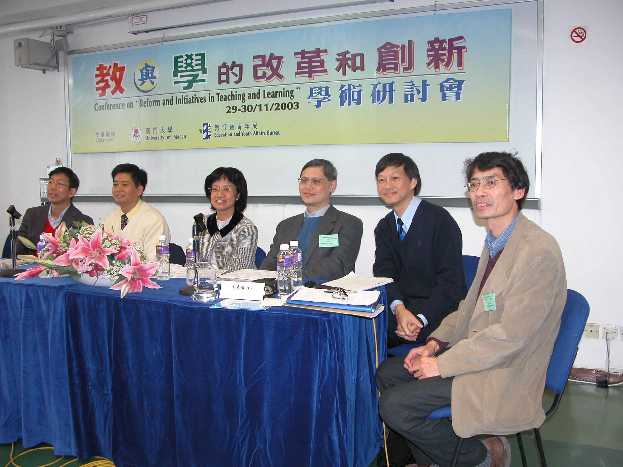
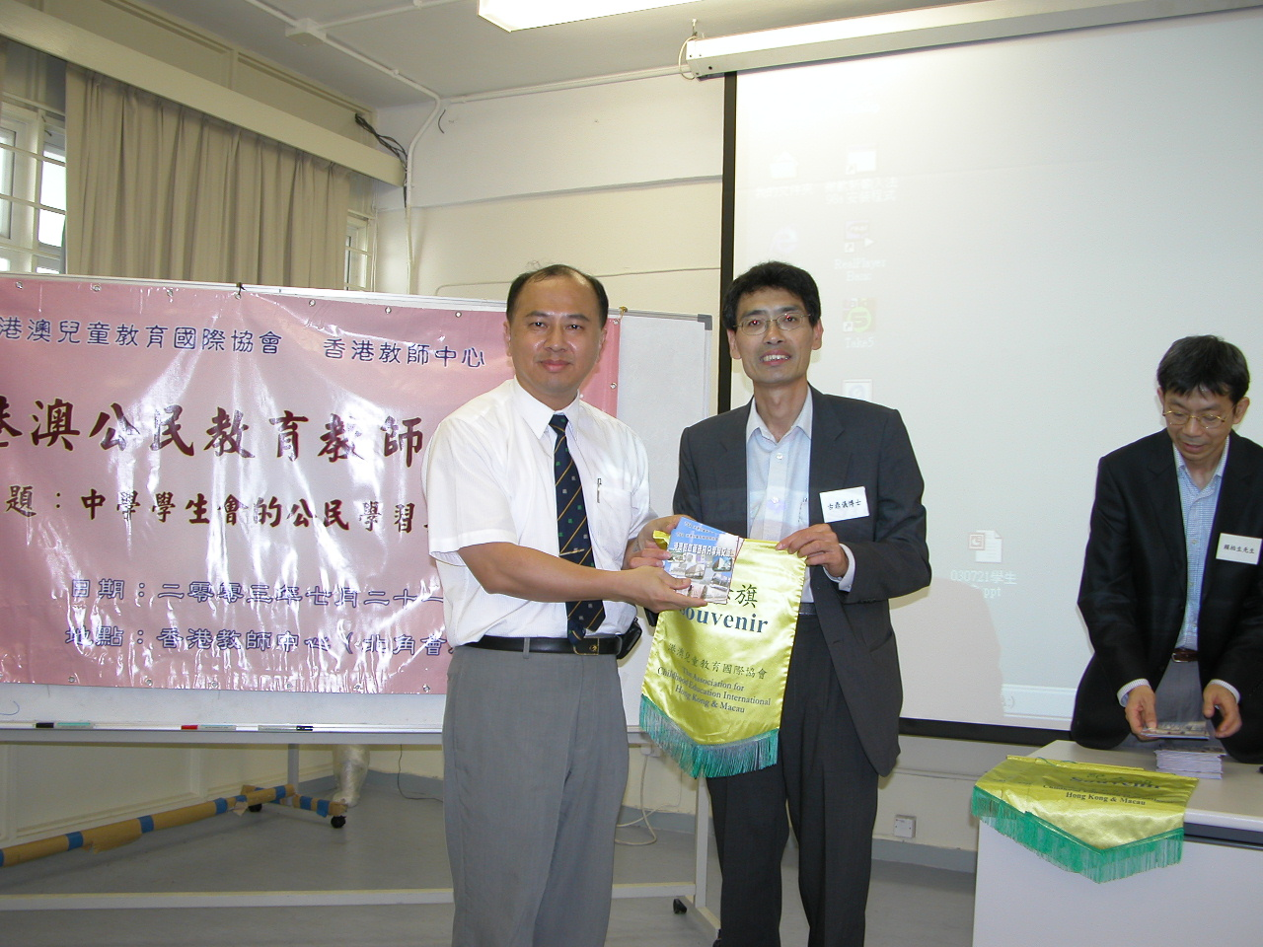
右上圖是本會執委會參與「教與學的改革和創新」學術研討會時所拍的合照。圖中至右方起分別是古鼎儀、蔡昌、甘志強、羅耀珍、李小鵬及賴柏生，而該日的論壇的主題為社會轉變與學校教育革新，這個國際研討會於2003年11月30日由澳門特別行政區政府教育暨青年局與澳門大學教育學院合辦。

香港數學競賽 梁興強
香港數學競賽(Hong Kong Mathematics Olympiad)是由香港教育統籌局數學組與香港教育學院數學系聯合主辦的。每年一度的香港數學競賽至今已是第二十屆。這項校際數學比賽，每年都吸引二百多所中學的千多人參與，可見其受歡迎的程度。這項活動，亦已成為中學數學教育課程以外的重要部份，它以靈活多變的問題，通過競賽的方式，讓學生從中思考及領略數學的原理，並加以掌握，從而達至舉一反三，觸類旁通的教學理想。如此，不但能培養學生參與的精神，更能將數學普及，同時提昇學生們的數學基礎。
數學是訓練思維的學科，只有多思考，多閱讀，多汲取前人優勝之處，才是進步的要訣。學生在分析、思考、解決問題時，多會想出創新的方法，這不單培養他們對數學的興趣，也讓他們對數學知識產生內發的追求，從而欣賞到數學美妙之處，更可培養他們獨立思考及分析的能力。

有興趣數學競賽的朋友可參閱香港教育圖書公司最近出版的《香港數學競賽必備手冊》，因為它匯集了前兩年香港數學競賽的題目與及題解分析，並向讀者介紹一些數學思維方法和解難技巧。相信掌握了這些技巧後，除了提高個人的解題速度之外，更能提升解決一般數學難題的能力，對數學解難有更深入的認識，並且能樂在數學思維之中。最後預告第二十一屆香港數學競賽決賽(Hong Kong Mathematics Olympiad)於公元二零零四年三月在香港教育學院擧行，屆時又有一番熱鬧了。
Surveying Juvenile Delinquency in Macau
A re-visit of the problem after ten years

A survey on the social causes of juvenile delinquency in Macao was conducted in 1994. Over 1000 primary and secondary pupils in randomly selected schools participated in the self-administered questionnaire survey. With a second and similar survey conducted in subsequent years, cohorts of relevant data are now available for making comparison on the issue of youth problems in Macao.

To follow up the changes related to the above issue after ten years, it is proposed that a new survey of the problems to be conducted in the coming year. This new survey will follow the format adopted in 1994 with some modifications of the old questionnaire according to the changing needs of the social context, and supplementary interviews to provide an in-depth analysis. This research project is funded by the ACEI-HK&M and supervised by Ben Choi and Titus Li. Comments and suggestions are welcome.
港澳課改下的教師專業發展
本會將於2004年3月13日(星期六)參與香港教師中心舉辦的2004年度《課程改革與教學實踐》教育會議活動，並主辦名為「港澳課改下的教師專業發展」的分組活動，時間為下午三時半至五時。屆時本會將邀請澳門學者、校長、教師和官員來港介紹澳門課改中教師專業發展的實踐，並邀請本港學者講述香港的有關情況，以促進港澳教育界對教師專業發展的交流和討論。
Perambulations in three education systems
Ben CHOI

From Hong Kong to Vancouver, and from Vancouver to Macao, I perambulate three cities during my course of life in recent years. Life is an observation project. I am delighted to share with ACEI readers some of my observations during the course of my stay in the three cities. Education is a broad term which comprises of various aspects. I shall limit my stories to education characteristics and classroom language in this short article.

The Ministry of Education in British Columbia plays a central role in monitoring education in the province. Specifically, it provides financial resources to facilitate the normal operation of educational services, especially foundation education. The Ministry is also responsible for the formulation and administration of region-wide education policy. Elementary and high schools in Vancouver are clustered in independent city boundary. Each of the cities in Greater Vancouver has a school board. This school board contains a group of public elected members who take care of the overall foundation education operations within the city, including the allocation of fund from the provincial government. The board meets monthly to decide matters like opening or closing of the school, or employing more multicultural teachers. The board will also make decisions to lay-off certain number of teaching staff when they experience a budget cut from the Ministry. In short, there are three-tiers of education operations in Vancouver: the Ministry, the school board, and the individual school. The school board members generally serve a two-year term. They are accountable to the whole community and will be “kick-out” if they do not satisfy the voters.

In contrast, schools in Hong Kong are mostly monitored by the Education and Manpower Bureau (EMB) of the Special Administrative Region. The Bureau is responsible for all affairs virtually related to education in the territory: from education policy to teacher qualifications and classroom language. Three main types of schools can be found in Hong Kong. One is the private schools and the other two are government schools and the subsidized schools. Subsidized schools are operated by non-profit organizations under government subsidy and must follow instructions from the Bureau. Recent education reform in Hong Kong aims at decentralizing decision-making from the Bureau to the schools. However, criticisms over the reform and the ways it takes to re-shape the education system are heard from time to time.

Comparatively, Macao has a distinctive education system from the two described above. Historically the Macao government had little control over private schools before the handover of sovereignty to Mainland China in 1999, hence private schools in the enclave have enjoyed substantial freedom in a way incomparable to other education systems over the world. In fact, the Macao education authority has fairly limited control over the daily operations of private schools. Over 90 per cent of primary and secondary schools in Macao are of this private category. Since 1991, the Macao government has launched a “buy-place school-net” policy to subsidize private schools. Through this financial means the Education and Youth Affairs Department (DSEJ) could gain better control to re-structure the development of education and to re-engineer the whole education system in preparing the city to cope with challenges in the new millennium. Like Hong Kong education reform in the late nineties, a new wave of education reform in Macao is under way in 2003. It is anticipated that a set of education laws will be enacted to provide a new outlook of school system in the territory.

In Vancouver Mainstream schools use English as their classroom language. Since Canada is an immigrant country, it is common to hear languages used by different ethnic groups within a school. Cities with many non-English speaking immigrant students have made effort to provide multicultural teaching assistants to help both the students and their parents in coping with the teaching and learning problems arising from their immigration situations.

For a long time, schools in Hong Kong have been in turmoil to adopt the appropriate kind of classroom language for students. Before 1997, English was used commonly and widely in secondary schools. After the handover, the mother-tongue instruction policy was enforced to satisfy the political demand of the new government and only a limited number (about 25%) of secondary schools were classified as having the qualifications to use English as the teaching language. Quite recently, yet many schools “silently” slip back to English as a medium of instruction to satisfy the needs of the business sector and the loud and clear demand from parents. Macao schools face even more complicated problems than Hong Kong or Vancouver in the use of classroom language. The territory was a Portuguese colony before 1999. Although Portuguese is an official language alongside Chinese after the handover, it is not actively introduced in schools and thus not commonly used in the Chinese community. As Macao has a population of over 90 per cent of Chinese background, schools have to make a choice to teach among the three sets of languages: Chinese, Portuguese and English. To add more complexity, Cantonese is the popular spoken dialect in Macao but its spoken form is very different from its written form. Thus, Macao schools have to contemplate in choosing among the three adopted languages (Chinese, Portuguese & English) plus the spoken form of Cantonese in classroom teaching and learning. Since most Macao schools are privately run by independent organizations and are relatively free from government constraints, a centrally planned language policy will inevitably be one of the many controversial issues in the education reform project in the years to come. We have seen that the education process can be understood more deeply if contextualized within wider frameworks. Vancouver, Hong Kong and Macao all have different sociocultural contexts and conditions associated with their education systems. However, one thing in common is that the Chinese factor has become an important consideration in their planning of education development and reform.
2004 ACEI Annual Conference
Annual International Conference and Exhibition will be held on the April 14-17 in New Orleans, Louisiana. The theme is “Practices, Policies, Procedures……And All That Jazz！”
website: http//www.udel.edu/bateman/acei/confex03.htm

港澳兒童教育國際協會執委會 (2003-2005)

會長 ﹕古鼎儀 | 出版 ﹕羅耀珍 | 澳門監事長 ﹕李寶田
副會長 ﹕李小鵬  副會長 ﹕甘志強 | 幼稚園召集人 ﹕鄭佩華  小學教育召集人﹕賴柏生 | 澳門副監事長 ﹕源妙姬  澳門監事 ﹕梁興強
秘書 ﹕胡少偉 | 中學教育召集人﹕阮衛華
財政 ﹕蔡昌 | 特殊教育召集人﹕區美蘭 | 澳門召集人 ﹕鄧愛貞
公關 ﹕容萬城 | 會員 ﹕黃國茜 | 澳門副召集人 ﹕陳祖揚

重慶殖民教育研討會後記 胡少偉

港澳回歸前皆分別受到英葡的殖民管治，回歸後又面對一連串非殖民地化的挑戰，欣聞西南師範大學教育科學學院主辦第六屆殖民主義研究年會暨重慶大轟炸65年周年紀念國際研討會，筆者與古鼎儀、甘志強和頼柏生三位同事於03年12月往渝赴會，從中了解內地與日韓學者對殖民主義的研究。在數天的會議討論和參觀中深有體會，現借此作一記述以分享見聞。

在筆者參與的研討會中，印象最深刻的是西南師大吳洪成教授的主題報告，他指出在研究日偽對中國淪陷區實施的奴化教育時，要看到上個世紀初列強在內地半殖民的歷史環境，也要了解自十九世紀末中日教育交流對中國的影響，才能為日本奴化教育研究有一個較全面的評價。至於中央教育科學研究所李玉非教授的發表，描述了日本侵略者在華北實施奴化教育的歷史，並分析了華北地區日佔區人民和抗日根據地軍民的反奴化和抗奴化的教育鬥爭。遼寧齊紅深研究員則介紹了一個關於日本侵華殖民地教育口述歷史的調查，從超過一千位親身經歷殖民教育的老人回憶中，描繪出日本侵華殖民教育的各種情況，這研究方法有別於內地教育歷史學者常用的文獻搜集、考察與分析，也十分值得港澳教育史學者作參考之用。

關於日本沖繩大學又吉盛清教授的發表，講述了沖繩殖民歷史及在二次大戰時沖繩人的雙重角色，沖繩人當時是日軍侵略的成員，卻又是戰爭的受害者。故此，沖繩人堅信和平，並提倡以自省和國際交流來促進各地人民為維護世界和平而努力。在研討會中，大會安排了日韓學者的全體參加者考察重慶戰時的文化遺址，當中包括上海復旦大學二次大戰時遷校的遺址、重慶大轟炸的紀念館、韓國流亡政府在重慶的原址及一個見證於戰時中美軍事合作的美國將軍紀念館。在參觀過程中，各地學者在看到戰爭時期的文物時，心情相當沉重﹔正如韓國東亞大學崔仁宅教授在閉幕時指出，他感受到日本學者在參觀時的矛盾心情，但對他們尊重歷史和追求和平的態度十分欣賞。想到港澳回歸只有幾年的歷史，兩地教育既受到前朝殖民教育的影響，但又恐防過分非殖民化的左傾思想破壞教育的穩定，如何處理好一些如國民教育和教學語言等敏感的教育問題，確實令港澳教育官員和學者頭痛。在此，筆者建議港澳教育界去了解各地的非殖民化教育的經驗，當中相信可令大家得到一些啟發，從中改善未來教育的發展策略。

